Computer Networks (Lab 01)
Syed Huzaifa Ali
BAI-6A

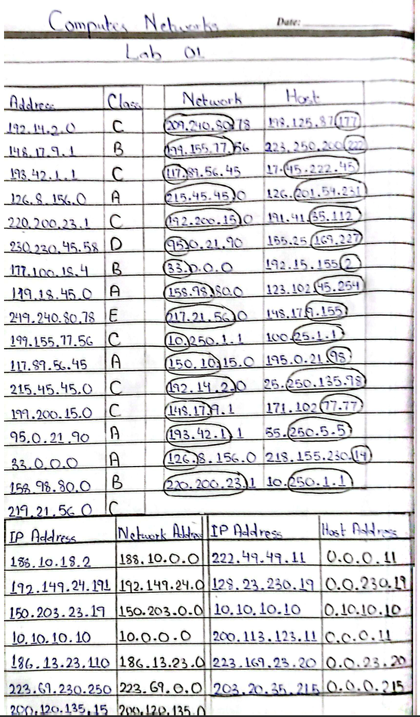
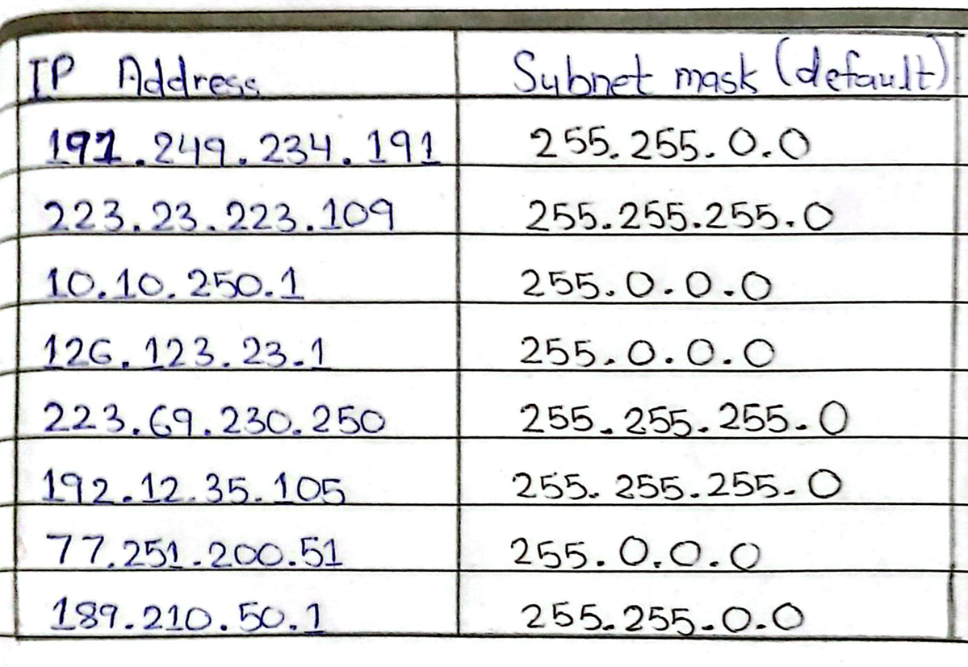

Tasks:

1) Find the IP address of the computer you are currently using.

Command: ipconfig
IP Address: 192.168.18.31
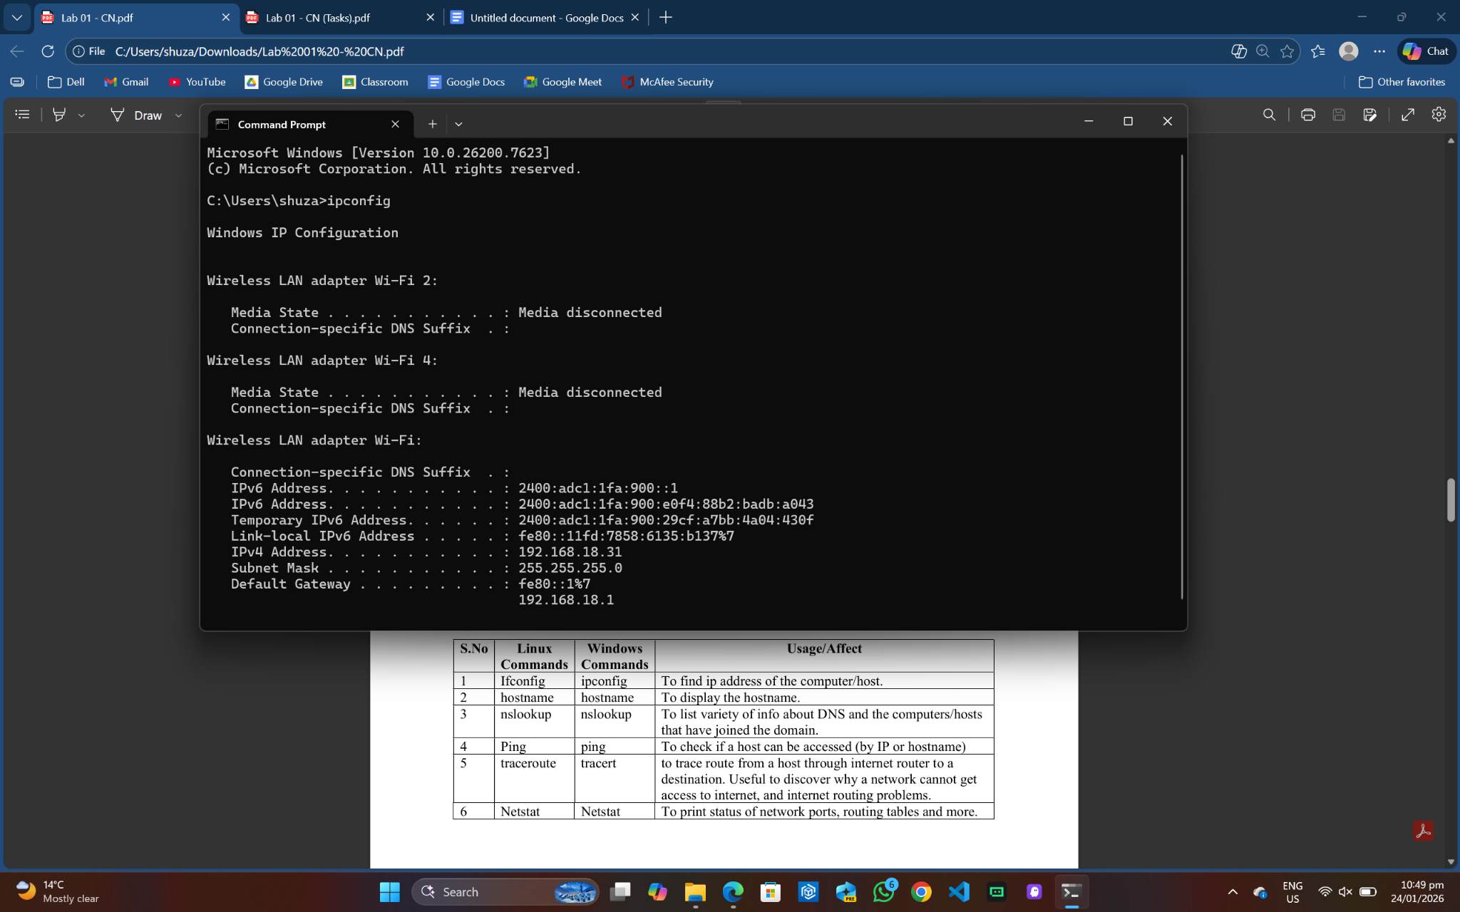

2) Find the IP address of the computer you are currently using, plus MAC address, the gateway, plus whether DHCP is turned on.

Command: ipconfig/all
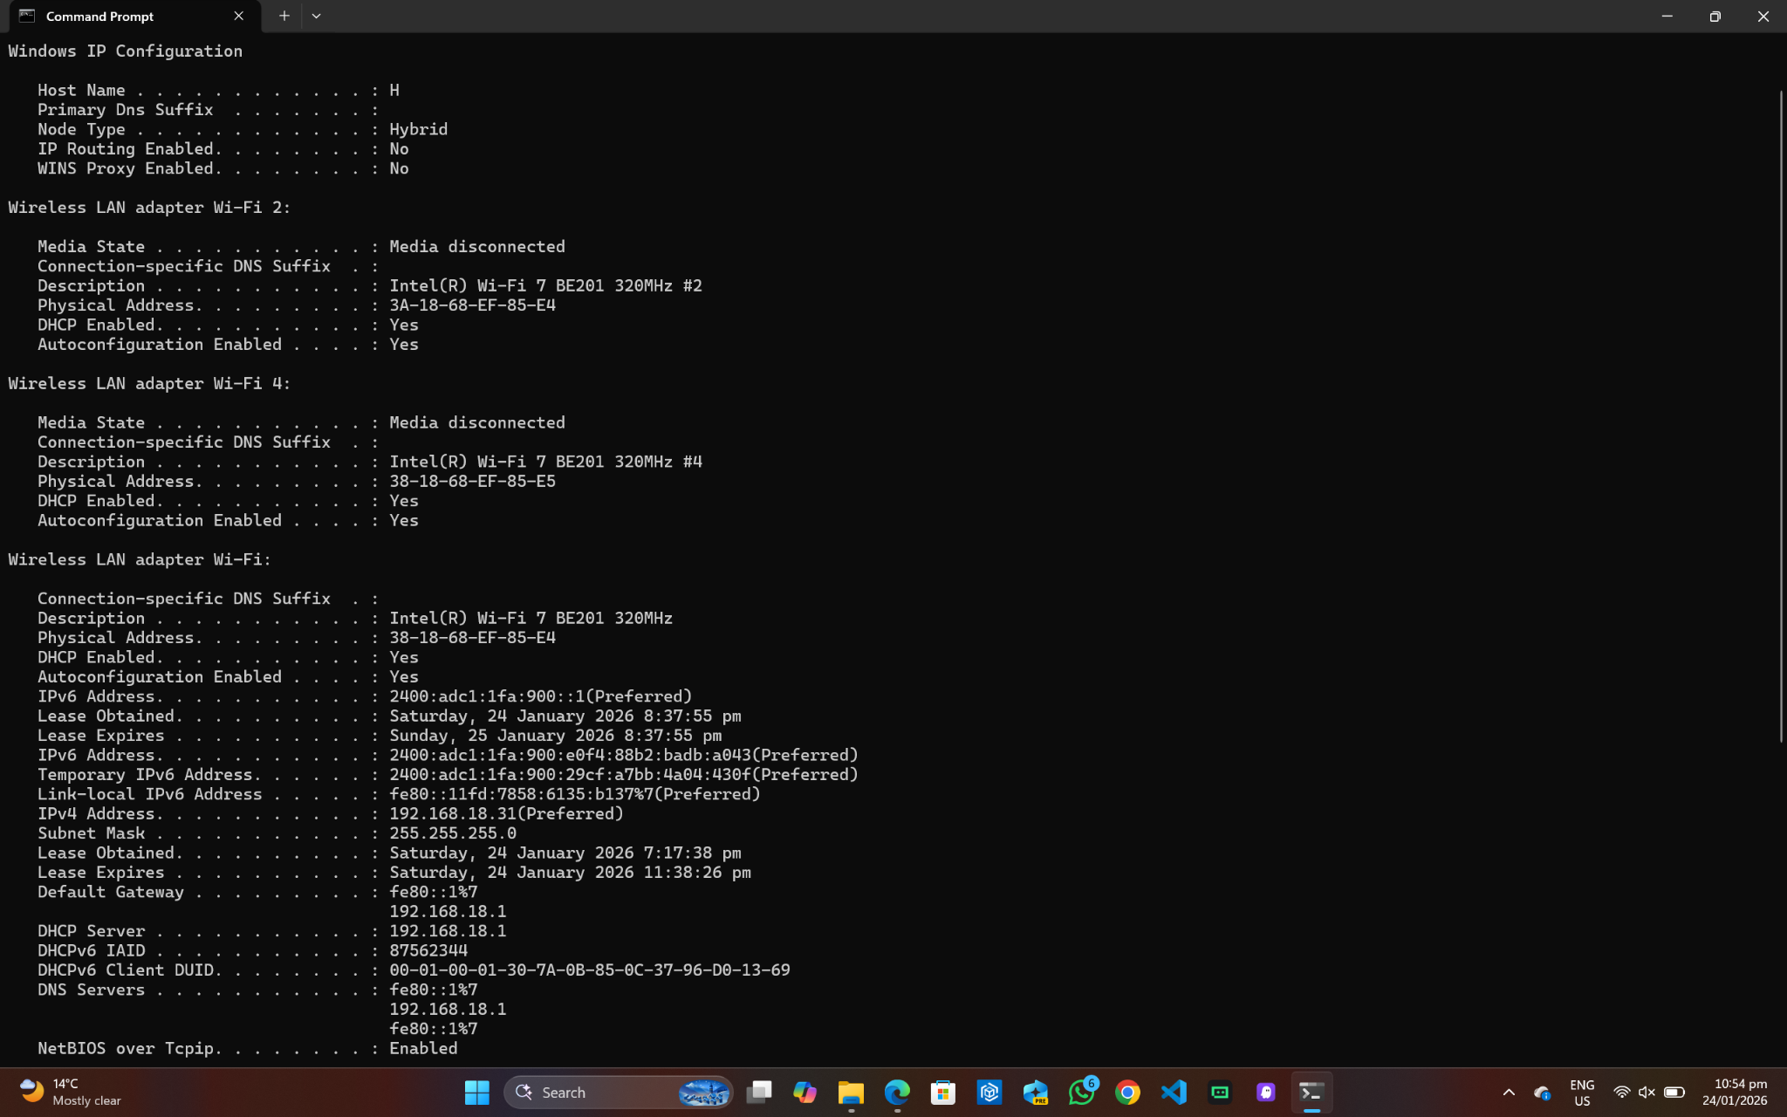

3) Display the host name of the computer.

Command: hostname
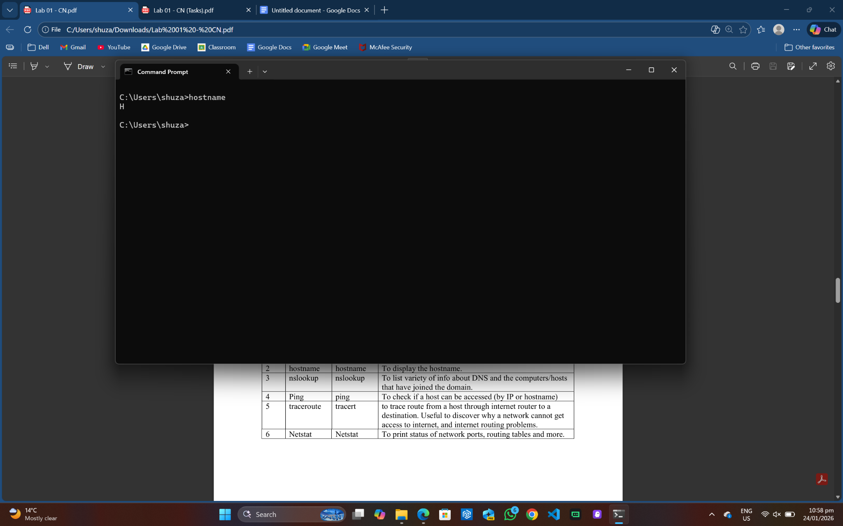

4) Check for basic IP connectivity between two computers by name and IP address. How can basic IP connectivity be checked? What are the reasons why there is no connectivity?

By IP Address: ping “IP Address”
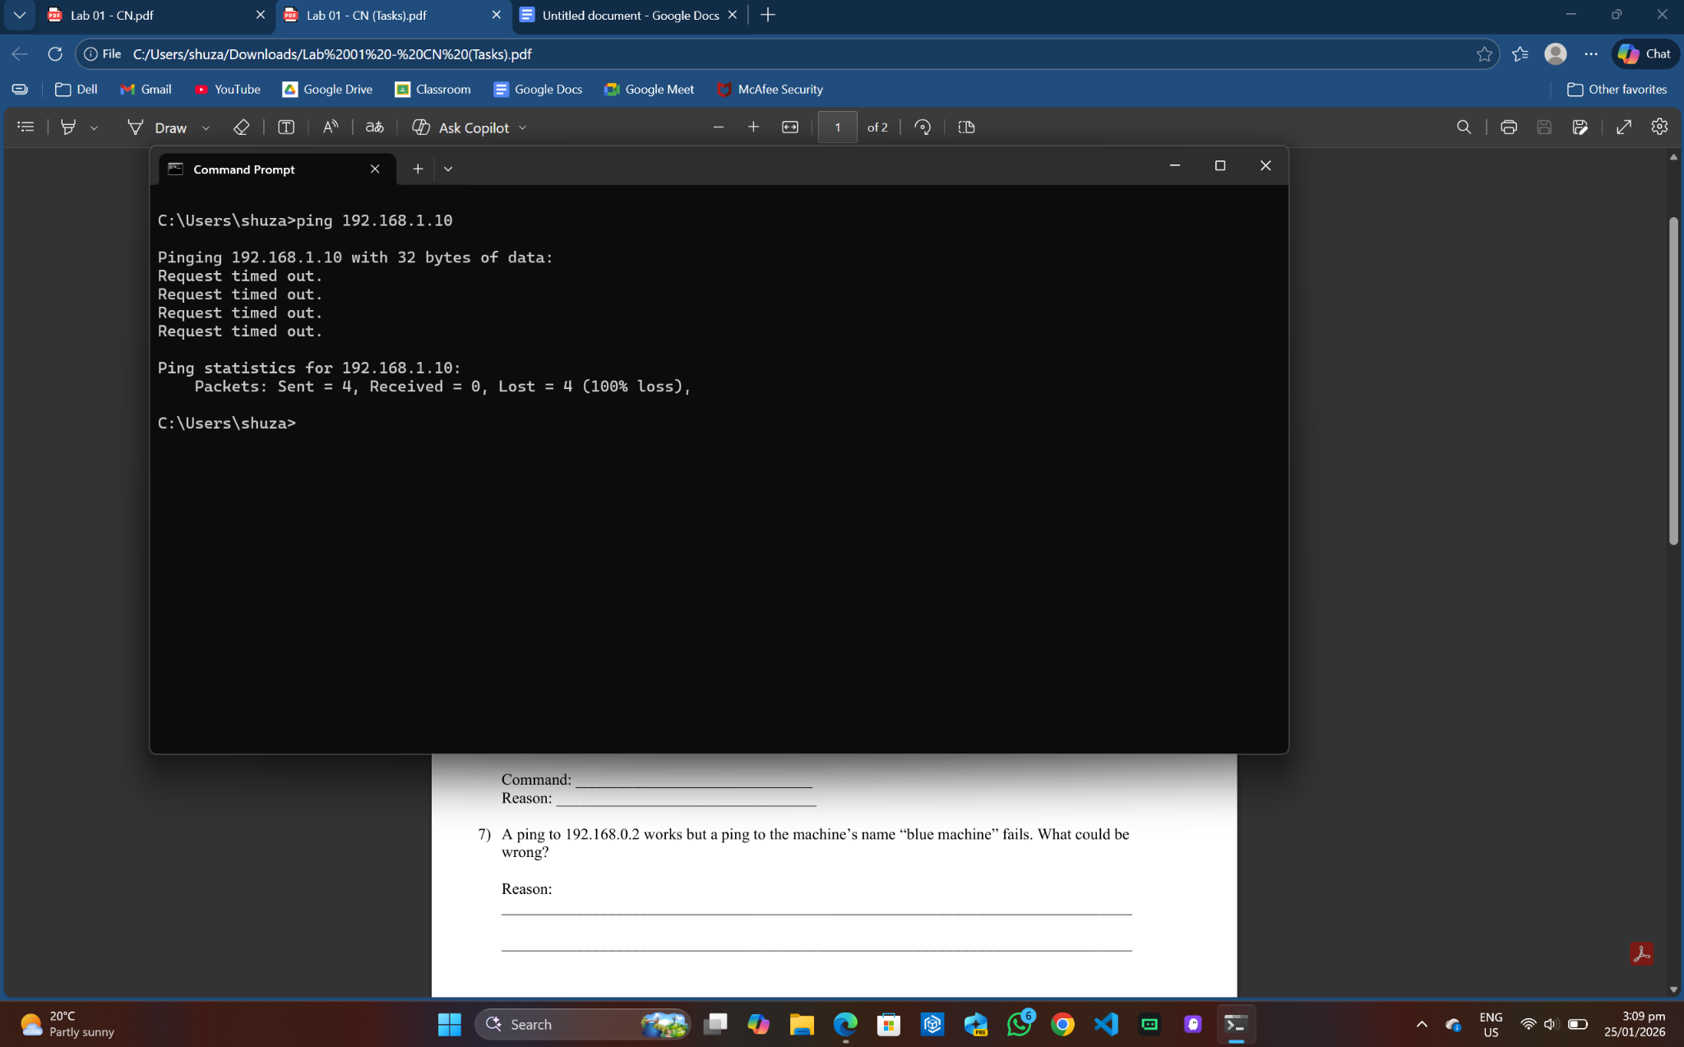

By Name: ping “DeviceName”
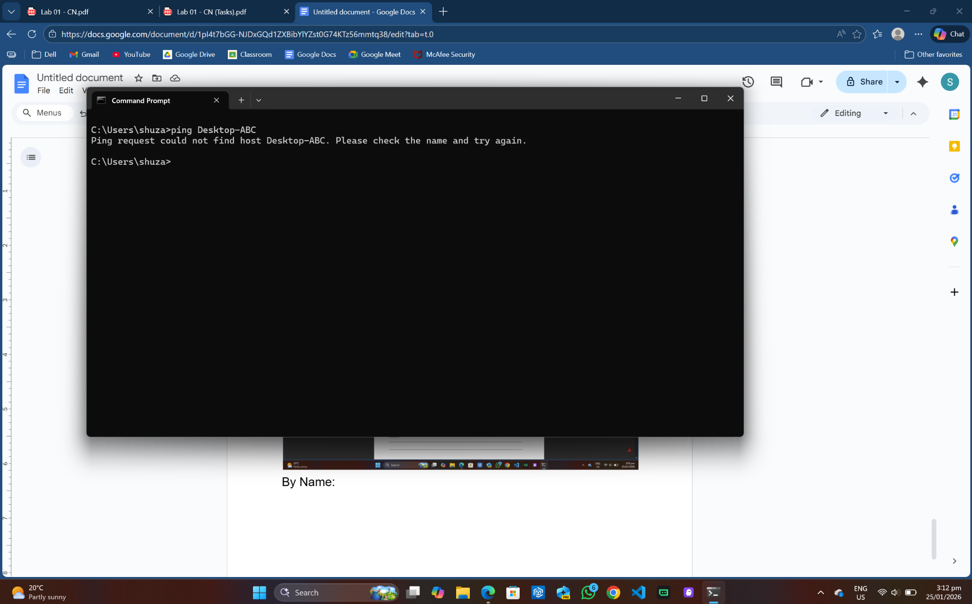
Reason: IP connectivity is checked using the ping command on command prompt. Ping command can be used with both the IP Address and the Computer Name. Lack of connectivity can be due to wrong IP address or computer name, target PC turned off, Wi-Fi not working.

5) Find out which ports on your host are connected to applications. Connect the browser to some external web page before running the appropriate command.

Command: netstat
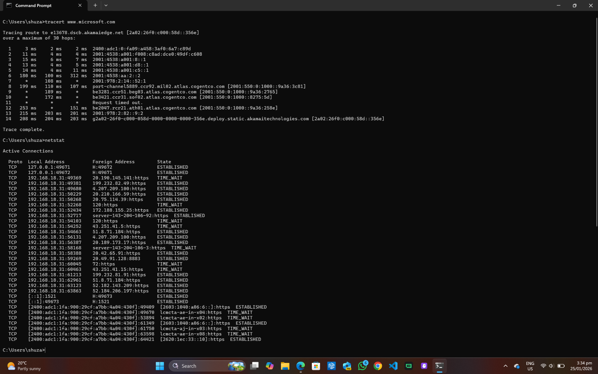
6) Find the path of routers to www.google.com.What is its IP address? How many hops involved in the path?

Command: tracert www.google.com
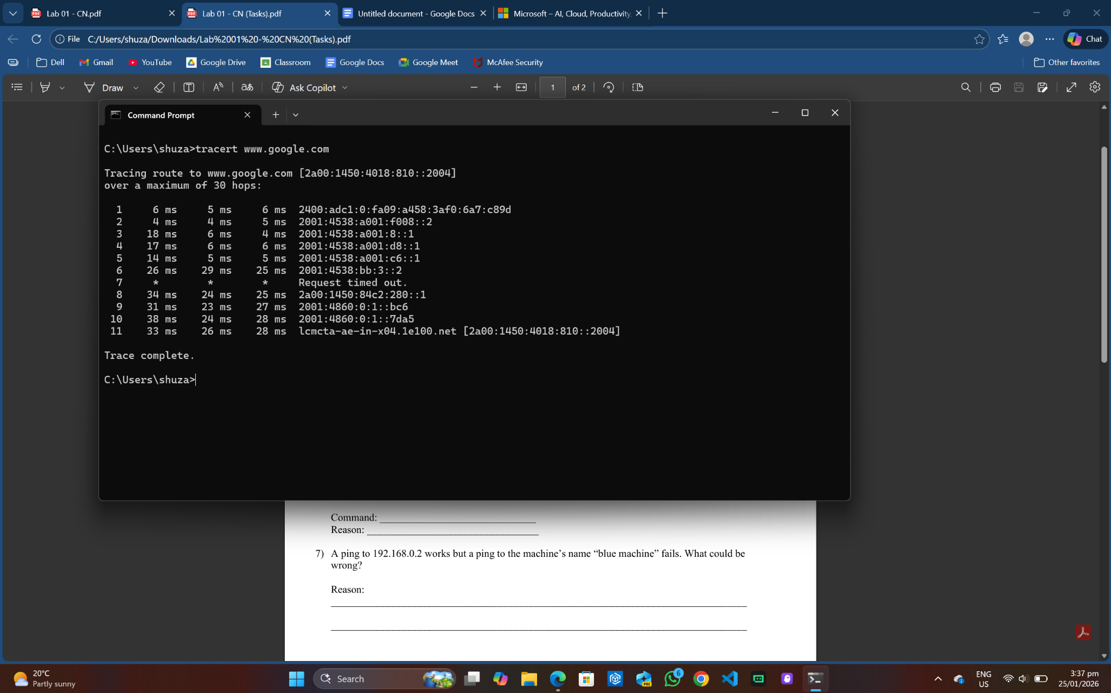

7) A ping to 192.168.0.2 works but a ping to the machine’s name “blue machine” fails. What could be wrong?

Reason: The DNS server might not be reachable or the device name is incorrect.

8) Which type of cable will you use to connect in a normal home installation?

Answer: A straight cable will be used in a normal home installation because it allows different types of devices to be connected together.

9) Can you connect a Switch to another Switch or a router to a PC using a straight- through cable? Explain your answer.

Answer: A router can be connected to a PC easily using a straight through cable as they are different types of devices, however, in order to connect 2 switches using a straight through cable, one switch should be connected using an uplink port and the other one using a normal port.

10) Write a brief report on your home network or any organizational network including topology, 1 page max).

Answer:
This report provides an overview of my home network, including its topology.

The home network follows a star topology where all devices are connected to a central device, the router.
Router: Provides internet connectivity and DHCP services.
Switch: Extends the number of wired connections.
Devices: Connected wirelessly to the router or via straight-through ethernet cables.
Internet: Provided by the ISP, connected to the router’s WAN port.

All devices can communicate within the LAN, and the router provides internet access for all the devices.

